# LIN RGB Specification for functional requirements of ambient light

**（secret）**

|  |  |  |
| --- | --- | --- |
| Revision: |  | V6.0 |
| Date: |  | 2020-09-17 |
| Status: |  | Draft |
| Department: |  | PMT 2 |
|  |  |  |
|  |  |  |
| Document Owner: |  | Sun Qiming |
| Project: |  | CD764 |

**Historical version**

| Version NO | Elaborate | Sign | Date |
| --- | --- | --- | --- |
| 0.1 | Initial release |  |  |
| 0.1.1 |  |  |  |
|  |  |  |  |
|  |  |  |  |
|  |  |  |  |
|  |  |  |  |
|  |  |  |  |
|  |  |  |  |

**Examine and Verify**

| Role | Name | Sign | Date |
| --- | --- | --- | --- |
|  |  |  |  |
|  |  |  |  |
|  |  |  |  |
|  |  |  |  |
|  |  |  |  |
|  |  |  |  |
|  |  |  |  |
|  |  |  |  |

**目录**

LIN RGB Specification for functional requirements of ambient light 1

1 Document description 6

1.1 Purpose 6

1.2 Scope of application 6

1.3 Reference documentation 6

1.4 Design and test standards 6

1.4.1 Design Standards 6

1.4.2 Test standards 6

2 Systems definition 7

2.1 System chart 7

2.2 Principle of components 9

2.3 LED zoning 10

2.4 Connector illustration 12

2.4.1 Connector model number 12

2.4.2 PIN Define 13

2.5 Input-output signal characteristics 13

2.5.1 Input signal characteristics 13

2.5.2 Output signal characteristics 16

2.6 Power management 16

2.6.1 Supply Voltage 16

2.6.2 Working current 17

2.6.3 Grounding requirements 17

2.7 Network Management 17

2.7.1 Wake up mode 17

2.7.2 Sleep mode 18

3 Function requirement 18

3.1 Work state 18

3.1.1 Wake up state 18

3.1.2 Sleeping state 19

3.1.3 Sleep Command 19

3.1.4 Welcome/farewell Function 20

3.1.5 Radar alarm 27

3.1.6 Driver Mode 29

3.1.7 Music rhythm 34

3.1.8 Static mode 32

3.1.9 Dynamic color 34

3.1.10 customize mode 42

3.1.11 Rest mode 45

3.1.12 Intensity define 49

3.2 ALM LIN feedback 50

3.3 ALM Priority definition 50

4 Color and Brightness define 53

5 Communication Interface 53

5.1 LIN communication 53

5.1.1 Interface type 53

5.1.2 Peripheral circuit 54

6 Environmental performance requirements 56

6.1 Temperature 56

6.2 Mechanical sector indicators 56

6.3 Appearance and mechanical structure 56

6.4 Fundamental performance parameter 57

6.5 EMC 57

6.6 Environmental suitability 57

6.7 Vibration test 57

6.8 Drop test 57

6.9 Mechanical impact test 57

6.10 Temperature and humidity resistance cycle 57

6.11 Switch durability 57

6.12 Normal voltage cycle 57

6.13 Waterproof and dustproof test 57

6.14 Resistance to abnormal power supply voltage 58

7 Other requirements 59

7.1 Oboundary dimension 59

7.2 outline dimension drawing of light source box 59

7.3 Weight 59

7.4 Installation position 59

7.5 Service life 59

7.6 Part marking requirements 59

7.7 Requirements for tooling, clamps, molds and inspection tools 59

7.8 Requirements for prohibited substances 60

7.9 Transportation and packaging requirements 60

Terminology

|  |  |  |
| --- | --- | --- |
| **Abbreviation** | **Full_name** | **Remarks** |
| CAN | Controller Area Network | CAN bus |
| LIN | Local Interconnect Network | LIN bus |
| PWM | Pulse Width Modulation | pulse duration modulation |
| TBD | To Be Determined | TBD |
| NA | Not Applicable | not applicable |
| …… | …… | …… |

# Document description

## Purpose

This document is a functional specification for the Ford Automotive Ambient light Module. It describes in detail the functions, component interfaces, technical parameters and dimensions of the Ambient light Module.

## Scope of application

This document is applicable to the design, develop and testing stages of cd764 vehicle project; during the implementation of the ford motor project, if there is any violation of this specification, it must be approved by ford motor.

## Reference documentation

| **Label** | **Title** | **Version/Modify Data** |
| --- | --- | --- |
| 1 |  |  |
| 2 |  |  |
| 3 |  |  |

## Design and test standards

### Design Standards

|  |  |  |
| --- | --- | --- |
| Num | Standard Name | Standard Number |
| 1 |  |  |
| 2 |  |  |
| 3 |  |  |
|  |  |  |

### Test standards

|  |  |  |
| --- | --- | --- |
| Num | Standards Name | Standard Number |
| 1 |  |  |
| 2 |  |  |

# Systems definition

## System chart

Low configuration system chart:

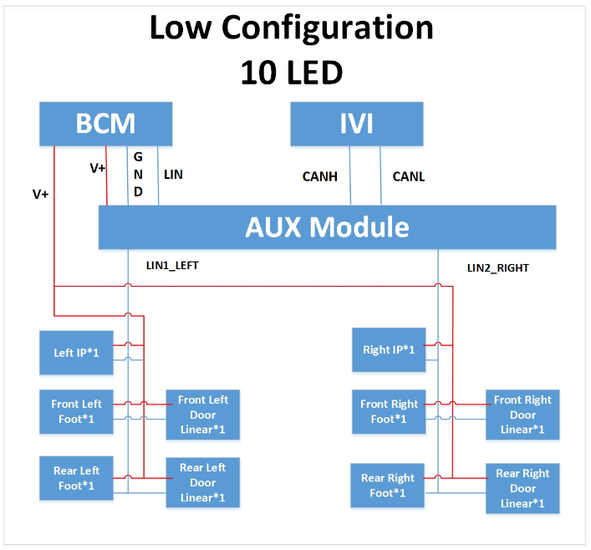

High configuration system chart:

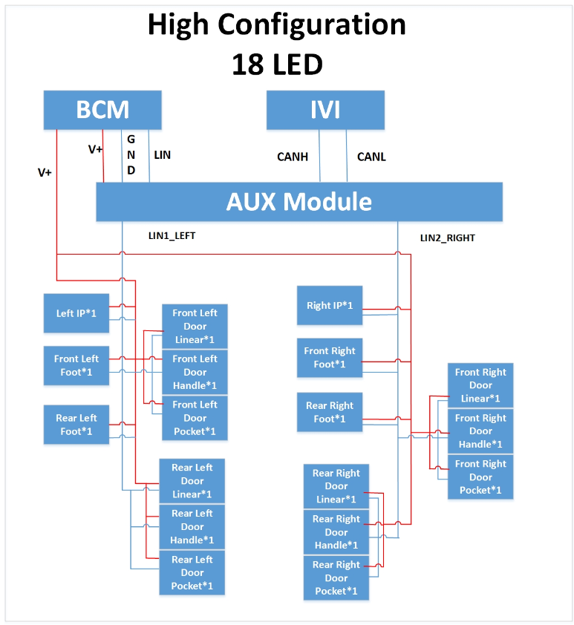

RGB Inner block of light head：

rgbled

GND

LIN

VCC

PIN1

PIN3

PIN2

ASIC

Rtemp

Rb

Rg

Rr

## Principle of components

1、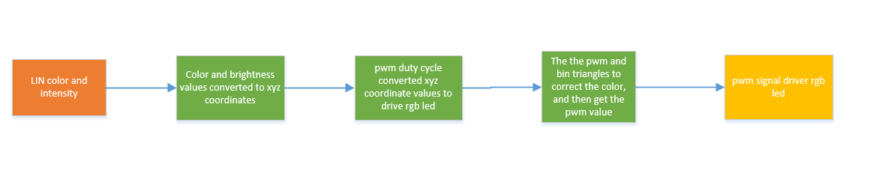

2、√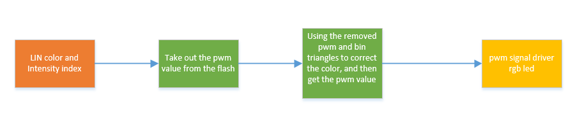

*Principle of components*



## LED zoning

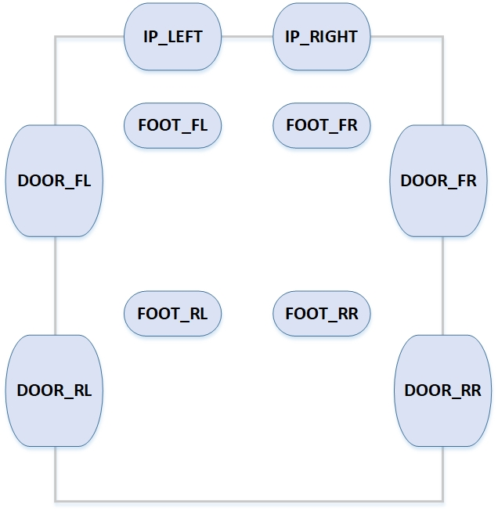

In low configuration, there are 10 LEDs:

Door Group:

* Front Left Door Linear 1 LED;
* Front Right Door Linear 1 LED;
* Rear Left Door Linear 1 LED;
* Rear Right Door Linear 1 LED;

IP Group:

* IP Left 1 LED;
* IP Right 1 LED;

Foot Group:

* Front Left Footage 1 LED;
* Front Right Footage 1 LED;
* Rear Left Footage 1 LED;
* Rear Right Footage 1 LED;

Maximum match 10 LED，each LED Allocation Independent ID.

Front Left Door Linear*1, Rear Left Door Linear*1, IP Left*1, Front Left Footage*1, Rear Left Footage*1 total 5 LEDs area shared the LIN1_LEFT.

Front Right Door Linear*1, Rear Right Door Linear*1, IP Right *1, Front Right Footage*1, Rear Right Footage*1 total 5 LEDs area shared the LIN2_RIGHT.

In high configuration, there are 18 LEDs:

Door Group:

* Front Left Door Linear 1 LED;
* Front Left Door Handle 1 LED;
* Front Left Door Pocket 1 LED;
* Front Right Door Linear 1 LED;
* Front Right Door Handle 1 LED;
* Front Right Door Pocket 1 LED;
* Rear Left Door Linear 1 LED;
* Rear Left Door Handle 1 LED;
* Rear Left Door Pocket 1 LED;
* Rear Right Door Linear 1 LED;
* Rear Right Door Handle 1 LED;
* Rear Right Door Pocket 1 LED;

IP Group:

* IP Left 1 LED;
* IP Right 1 LED;

Foot Group:

* Front Left Footage 1 LED;
* Front Right Footage 1 LED;
* Rear Left Footage 1 LED;
* Rear Right Footage 1 LED;

Maximum match 18 LED，each LED Allocation Independent ID.

Front Left Door Linear*1, Front Left Door Handle*1, Front Left Door Pocket *1, Rear Left Door Linear*1, Rear Left Door Handle*1, Rear Left Door Pocket *1, IP Left*1, Front Left Footage*1, Rear Left Footage*1 total 9 LEDs area shared the LIN1_LEFT.

Front Right Door Linear*1, Front Right Door Handle*1, Front Right Door Pocket *1, Rear Right Door Linear*1, Rear Right Door Handle*1, Rear Right Door Pocket *1, IP Right *1, Front Right Footage*1, Rear Right Footage*1 total 9 LEDs area shared the LIN2_RIGHT.

## Connector illustration

### Connector model number

the schematic diagram of the side connector of the Ambient light module is as follows:

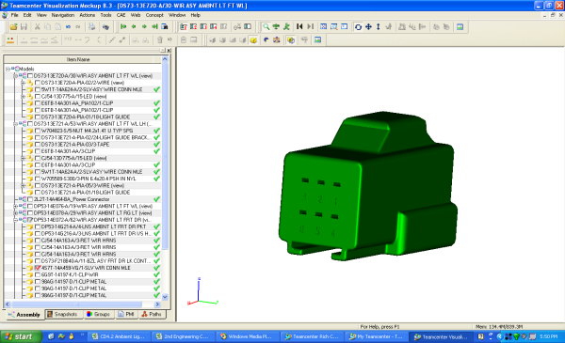

1. **111**
2. **0**

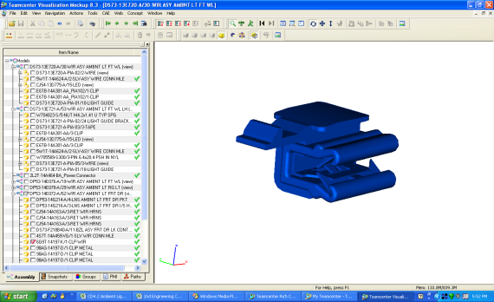

Connector model number is as follows:

|  |  |
| --- | --- |
| Info | Connector |
| Model num | **4S7T-14A459-VG/1L2T-14421-BA/W716663-S** |
| Pic num |  |
| Type |  |
| Color |  |
| Supplier |  |
| Match Connector model num |  |

### PIN Define

Connector ：

|  |  |  |
| --- | --- | --- |
| PIN | PIN Define | Describe |
| 1 | VCC | 12V+ |
| 2 | LIN-in | LIN signal |
| 3 | GND | 12V- |
| 4 | Lin-out | Tbd |

## Input-output signal characteristics

### Input signal characteristics

Hardline signal

|  |  |  |
| --- | --- | --- |
| Signal | Signal description | effective value |
| VCC | Power supply for ambient light | voltage range：9~16V  rated voltage：12V |
| LIN | LIN communication signals |  |
| GND | GND supply for ambient light | 0V |

LIN BUS Signal:

|  |  |  |  |  |
| --- | --- | --- | --- | --- |
| **Signal Name** | **Signal Desc** | **Lent** | **value** | **FROM** |
| **(bit)** |
| Aux_Static_Intensity_Value | 静态亮度设置 | 7 | 0-100(%) | IVI |
| Aux_Static_Color_Value | 静态颜色设置 | 8 | 0-255(color num) | IVI |
| Aux_IP_Intensity_Value | IP group亮度设置 | 7 | 0-100(%) | IVI |
| Aux_IP_Group_Set | IP group是否打开 | 1 | 0:close 1:open | IVI |
| Aux_IP_Color_Value | IP group颜色设置 | 8 | 0-255(color num) | IVI |
| Aux_Door_Intensity_Value | Door group亮度设置 | 7 | 0-100(%) | IVI |
| Aux_Door_Group_Set | Door group是否打开 | 1 | 0:close 1:open | IVI |
| Aux_Door_Color_Value | Door group颜色设置 | 8 | 0-255(color num) | IVI |
| Aux_Foot_Intensity_Value | Foot group亮度设置 | 7 | 0-100(%) | IVI |
| Aux_Foot_Group_Set | Foot group是否打开 | 1 | 0:close 1:open | IVI |
| Aux_Foot_Color_Value | Foot group颜色设置 | 8 | 0-255(color num) | IVI |
| Aux_ALM_Set | 室内氛围灯开关 | 2 | 0:invalid 1:close 2:open | IVI |
| Aux_Color_Mode | 颜色模式设置 | 3 | 0:invalid  1:static  2:dynamic  3:customize  4:music | IVI |
| Aux_Dynamic_Color | 动态颜色设置 | 3 | 0:invalid 1:surprise me 2:ocean heart 3:deep forest 4:Moden city 5:warm heart | IVI |
| Aux_AmbLghtDrvMde_D_Rq | IVI颜色模式 | 1 | 0:manual 1:auto | IVI |
| Aux_Customer_Color | SDM mode color index | 2 | 1:normal-Orange  2:eco-Soft Blue  3:sport-red | BCM LIN |
| Aux_WelcomeFarewell_State | Farewell | 2 | 0:invalid  1: welcome  2: farewell  3: run_start | BCM |
| Aux_WelcomeFarewell_Substate | SubFarewell | 3 | 0:NULL  1:Approach  2:IlluminatedEntry  3:CourtesyLightingAll  4:CourtesyLightingDelayAll  5:CourtesyLightingExtended  6:CourtesyLightingDelayExt  7:IlluminatedExit | BCM |
| Aux_Day_Night_Status | 白天夜晚状态 | 2 | 0:NULL 1:Day 2:Night 3:NotUsed | BCM |
| Aux_ClrExitAsstMsgTxt_D_Rq2 | 雷达报警状态 | 4 | 0:No Info/Warning  1:Rear Left  2:Rear Right  3:Front Left  4:Front Right  5:Rear Left And Rear Right  6:Front Left And Front Right  7:Rear Left And Front Right  8:Front Left And Rear Right | ADAS |
| Aux_DF_Door_Ajar_Status | 左前门 | 1 | 0:closed 1:AJAR | BCM |
| Aux_PF_Door_Ajar_Status | 右前门 | 1 | 0:closed 1:AJAR | BCM |
| Aux_Music_Rate_Level | 音乐律动频率等级 | 4 | 0:0-63hz 1:64-127hz 2:128-255hz 3:256-511hz 4:512-1023hz 5:1023-2047hz 6:2048-4095hz 7:4096-8191hz 8:8192-16383hz | IVI |
| Aux_Music_Range_Level | 音乐律动幅度等级 | 3 | 0:0-15 1:16-31 2:32-47 3:48-63 4:64-79 5:80-95 6:96-111 7:112-127 | IVI |
| Aux_DR_Door_Ajar_Status | 左后门 | 1 | 0:closed 1:AJAR | BCM |
| Aux_PR_Door_Ajar_Status | 右后门 | 1 | 0:closed 1:AJAR | BCM |
| Aux_Sync_Signal | 同步信号 | 6 | 0-63(tick) | AUX |
| Aux_ClrExitAsst_D_Stat | 雷达状态是否有效标记 | 2 | 0:Null  1:Disabled  2:Enabled | ADAS |

### Output signal characteristics

## Power management

### Supply Voltage

rated voltage：12V；

test voltage：13.5V±0.2V

Working condition：

|  |  |  |
| --- | --- | --- |
| Voltage Range | Voltage Description | Functional description at different voltages |
| Volt <6V | Ultra-low Vol mode | All functions prohibited |
| 6V≤Volt<9V | low Vol mode | LED light lose all functions，Communication function is normal |
| 9V≤Volt<16V | normal Vol mode | All functions is normal |
| 16V≤Volt＜18V | High Vol mode | LED light lose all functions，Communication function is normal |
| 18V≤Volt | Ultra-High Vol mode | All functions prohibited |

Note: The data provided by the supplier shall prevail.

### Working current

|  |  |
| --- | --- |
| Current | Current value |
| Rated current（LED ON） | 0.1A |
| MAX current | 0.3A |
| Quiescent current （LED OFF） | 100uA |

Note: The data provided by the supplier shall prevail.

### Grounding requirements

N/A

## Network Management

### Wake up mode

any node in a dormant lin cluster state can request a wake-up program (the host can send an interval symbol, for example, a normal frame header, as the interval will act as a wake-up pulse). Wake-up requests can be generated by leaving the bus in a dominant state μs 250 to 5 ms,. each slave node (connected to the power supply) shall be able to detect a wake-up request (the main pulse is not longer than 150μ), and will be waiting for the bus command within 100 ms. ms 100 is calculated from the termination edge of the main pulse. Hosts are woken up, and it takes 100 ms when the slave node is ready (starting with the wake-up), unless the host has additional information, for example, that the reason for the wake-up is simply because one of the slave in the cluster. ), the host node starts sending the frame header and starts probing the cause of the wake-up request release. if the host does not send the frame header within 150 ms of receiving the wake-up request, then the node that sent the request can attempt to send a new wake-up request. After three requests (all failed), the node should wait at least 1.5 seconds before sending the fourth wake-up request.

From sleep mode to wake-up mode when any of the following conditions are satisfied:

1. controlled by aux module power supply, and the ambient light module works after power on.
2. A wake-up signal sent by the aux module is received from the node;

### Sleep mode

all slave nodes in the active cluster are forced into sleep mode by sending a diagnostic host request frame (identifier of the frame =0 x3c)(sleep state only covers the cluster. applications within nodes are still activated). the first data byte of the request frame is equal to 0(normally, the first data byte is interpreted as a node address, i.e. nad; address is not allowed to be zero). If the lin bus has been inactive for more than 4 seconds, the slave node automatically enters sleep mode.

Go to sleep mode when any of the following conditions are satisfied:

1. AUX module After the power is disconnected, the ambient light module stops working.
2. AUX module sends sleep signals to slave nodes；

# Function requirement

## Work state

### Wake up state

#### Function description:

Wake up：wake up when the ambient light module detects bus activity.

#### Signal description:

There are messages on the bus.

#### 3.1.1.3 Functional logic/specific functional description:

1. **Enabling conditions：(a & b & c & d)**
2. Power supply voltage within normal operating range
3. LIN communication normal
4. LED function normal
5. Temperature within normal range
6. **Trigger conditions：**
7. Bus from inactive to transmitted
8. **Execute output：**

The ambient light module wakes up and enters the working state.

### Sleeping state

#### Function description:

Sleeping：after receiving the sleep command or the LIN bus has been inactive for more than 4 seconds, enter hibernation state.

#### Signal description:

Sleep message sent or the LIN bus has been inactive for more than 4 seconds.

#### 3.1.2.3 Functional logic/specific functional description:

1. **Enabling conditions：(a & b & c & d)**
2. Power supply voltage within normal operating range
3. LIN communication normal
4. LED function normal
5. Temperature within normal range
6. **Trigger conditions：**
7. Bus sleep message.
8. **Execute output：**

The ambient light module enters sleeping state.

### Sleep Command

#### Function description:

The ambient light module into sleeping state.

#### Signal description:

1. Bus input signal as follows:

| **Signal Name** | **Signal Desc** | **Signal len** | **Signal len desc** | **note** |
| --- | --- | --- | --- | --- |
| ID | addr | 1 byte |  |  |

#### Functional logic/specific functional description:

1. **Enabling conditions：(a & b & c & d)**
2. Power supply voltage within normal operating range
3. LIN communication normal
4. LED function normal
5. Temperature within normal range
6. **Trigger conditions：**

AUX module send sleep message on the bus.

1. **Execute output：**

Go to sleep mode.

### Welcome/farewell Function

#### Welcome Start：

Function description:：Welcome mode start

Signal description:

Bus input signal as follows:

|  |  |  |  |  |
| --- | --- | --- | --- | --- |
| Signal Name | Signal Desc | Signal Len | Signal Value Desc | note |
| Aux_WelcomeFarewell_State | Welcome | 2 | 0:invalid  1: welcome  2: farewell  3: run_start | BCM |
| Aux_WelcomeFarewell_Substate | CourtesyLightingAll | 3 | 0:NULL  1:Approach  2:IlluminatedEntry  3:CourtesyLightingAll  4:CourtesyLightingDelayAll  5:CourtesyLightingExtended  6:CourtesyLightingDelayExt  7:IlluminatedExit | BCM |

|  |  |  |  |  |
| --- | --- | --- | --- | --- |
| Aux_Day_Night_Status | 白天夜晚状态 | 2 | 0:NULL 1:Day 2:Night 3:NotUsed | BCM |

1. Enabling conditions：（A＆B＆C&D）

1. Power supply voltage within normal operating range
2. LIN communication normal
3. LED function normal
4. Temperature within normal range
5. Trigger conditions：：（A＆B）
6. Aux_WelcomeFarewell_State = Welcome
7. Aux_WelcomeFarewell_Substate = CourtesyLightingAll

3. Execute output：

1. All Ambient Lighting Fade ON (3s)
2. Selected Color：

* If Aux_Color_Mode= static, Selected Color= Aux_Static_Color_Value;
* If Aux_Color_Mode= dynamic, Selected Color= Aux_Dynamic_Color’s first color;
* If Aux_Color_Mode= customize and Aux_IP_Group_Set= open or Aux_Door_Group_Set = open or Aux_Foot_Group_Set = open, Selected Color= Aux_IP_Color_Value or Aux_Door_Color_Value or Aux_Foot_Color_Value;
* If Aux_Color_Mode= customize and Aux_IP_Group_Set= close and Aux_Door_Group_Set = close and Aux_Foot_Group_Set = close, Selected Color=white
* If Aux_Color_Mode= music, Selected Color=white

4. Flow chart：

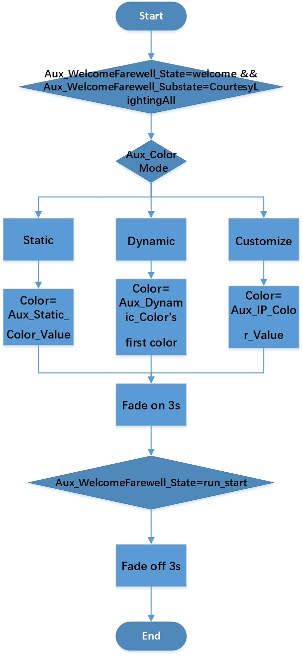

#### Welcome Stop：

Function description：Welcome mode stop

Signal description:

Bus input signal as follows:

|  |  |  |  |  |
| --- | --- | --- | --- | --- |
| Signal Name | Signal Desc | Signal Len | Signal Value Desc | note |

|  |  |  |  |  |
| --- | --- | --- | --- | --- |
| Aux_Day_Night_Status | 白天夜晚状态 | 2 | 0:NULL 1:Day 2:Night 3:NotUsed | BCM |

|  |  |  |  |  |
| --- | --- | --- | --- | --- |
| Aux_WelcomeFarewell_State | run_start | 2 | 0:invalid  1: welcome  2: farewell  3: run_start | BCM |

1. Enabling conditions：（A＆B＆C&D）

1. Power supply voltage within normal operating range
2. LIN communication normal
3. LED function normal
4. Temperature within normal range
5. Trigger conditions: (A）
6. Aux_WelcomeFarewell_State = run_start

3. Execute output：

1. All Ambient Lighting Fade OFF (3s)
2. Selected Color at 0% Intensity

#### 3.1.4.3 Farewell（Start）：

Function description: Farewell mode start

Signal description:

Bus input signal as follows:

|  |  |  |  |  |
| --- | --- | --- | --- | --- |
| Signal Name | Signal Desc | Signal Len | Signal Value Desc | note |

|  |  |  |  |  |
| --- | --- | --- | --- | --- |
| Aux_Day_Night_Status | 白天夜晚状态 | 2 | 0:NULL 1:Day 2:Night 3:NotUsed | BCM |

|  |  |  |  |  |
| --- | --- | --- | --- | --- |
| Aux_WelcomeFarewell_State | Farewell | 2 | 0:invalid  1: welcome  2: farewell  3: run_start | BCM |
| Aux_WelcomeFarewell_Substate | IlluminatedExit | 3 | 0:NULL  1:Approach  2:IlluminatedEntry  3:CourtesyLightingAll  4:CourtesyLightingDelayAll  5:CourtesyLightingExtended  6:CourtesyLightingDelayExt  7:IlluminatedExit | BCM |

1. Enabling conditions：（A＆B＆C&D）

A. Power supply voltage within normal operating range.

B. LIN communication normal.

C. LED function normal.

D. Temperature within normal range

2．Trigger conditions:（A＆B）

1. Aux_WelcomeFarewell_State = Farewell
2. Aux_WelcomeFarewell_Substate = IlluminatedExit

3．Execute output:

A. If Ambient Lighting is now ON, use the last status.

B. If Ambient Lighting is now OFF, the color select like “3.1.4.1 Welcome Start”.

4. Flow chart：

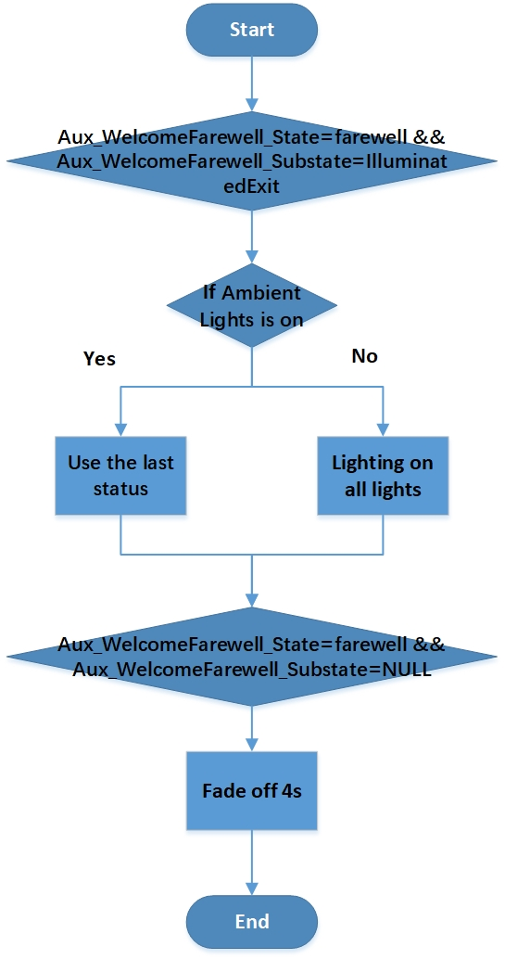

#### 3.1.4.4 Farewell Stop：

Function description: farewell for lock

Signal description:

Bus input signal as follows:

|  |  |  |  |  |
| --- | --- | --- | --- | --- |
| Signal Name | Signal Desc | Signal Len | Signal Value Desc | note |

|  |  |  |  |  |
| --- | --- | --- | --- | --- |
| Aux_Day_Night_Status | 白天夜晚状态 | 2 | 0:NULL 1:Day 2:Night 3:NotUsed | BCM |

|  |  |  |  |  |
| --- | --- | --- | --- | --- |
| Aux_WelcomeFarewell_State | Farewell | 2 | 0:invalid  1: welcome  2: farewell  3: run_start | BCM |
| Aux_WelcomeFarewell_Substate | NULL | 3 | 0:NULL  1:Approach  2:IlluminatedEntry  3:CourtesyLightingAll  4:CourtesyLightingDelayAll  5:CourtesyLightingExtended  6:CourtesyLightingDelayExt  7:IlluminatedExit | BCM |

1. Enabling conditions：（A＆B＆C&D）

A. Power supply voltage within normal operating range.

B. LIN communication normal.

C. LED function normal.

D. Temperature within normal range

2. Trigger conditions：（A&B）

1. Aux_WelcomeFarewell_State = Farewell
2. Aux_WelcomeFarewell_Substate = NULL

3. Execute output:

A、All Ambient Lighting Fade OFF 4s

### 3.1.5 Radar alarm

Function description

Alarm when anyone of radar is ON when door is ajar.

Signal description

Bus input signal as follows:

|  |  |  |  |  |
| --- | --- | --- | --- | --- |
| Signal Name | Signal Desc | Signal Len | Signal Value Desc | note |
| Aux_ClrExitAsstMsgTxt_D_Rq2 | 1-8 | 4 | 0:No Info/Warning  1:Rear Left  2:Rear Right  3:Front Left  4:Front Right  5:Rear Left And Rear Right  6:Front Left And Front Right  7:Rear Left And Front Right  8:Front Left And Rear Right | ADAS |
| Aux_ClrExitAsst_D_Stat | 2 | 2 | 0:Null  1:Disabled  2:Enabled | ADAS |
| Aux_DF_Door_Ajar_Status | AJAR | 1 | 0:closed 1:AJAR | BCM |
| Aux_PF_Door_Ajar_Status | AJAR | 1 | 0:closed 1:AJAR | BCM |
| Aux_DR_Door_Ajar_Status | AJAR | 1 | 0:closed 1:AJAR | BCM |
| Aux_PR_Door_Ajar_Status | AJAR | 1 | 0:closed 1:AJAR | BCM |

Function description

1. Enabling conditions：（A＆B＆C&D）

A. Power supply voltage within normal operating range.

B. LIN communication normal.

C. LED function normal.

D. Temperature within normal range

2. Trigger conditions：(A and (B or C or D or E or F or G or H or I))

A、Aux_ClrExitAsst_D_Stat=Enabled

B、Aux_ClrExitAsstMsgTxt_D_Rq2= Front Left && Aux_DF_Door_Ajar_Status= AJAR

C、Aux_ClrExitAsstMsgTxt_D_Rq2= Front Right && Aux_PF_Door_Ajar_Status= AJAR

D、Aux_ClrExitAsstMsgTxt_D_Rq2= Rear Left && Aux_DR_Door_Ajar_Status= AJAR

E、Aux_ClrExitAsstMsgTxt_D_Rq2= Rear Right && Aux_PR_Door_Ajar_Status= AJAR

F、Aux_ClrExitAsstMsgTxt_D_Rq2= Rear Left And Rear Right && (Aux_DR_Door_Ajar_Status= AJAR || Aux_PR_Door_Ajar_Status= AJAR)

G、Aux_ClrExitAsstMsgTxt_D_Rq2= Front Left And Front Right && (Aux_DF_Door_Ajar_Status= AJAR || Aux_PF_Door_Ajar_Status= AJAR)

H、Aux_ClrExitAsstMsgTxt_D_Rq2= Rear Left And Front Right && (Aux_DR_Door_Ajar_Status= AJAR || Aux_PF_Door_Ajar_Status= AJAR)

I、Aux_ClrExitAsstMsgTxt_D_Rq2= Front Left And Rear Right && (Aux_DF_Door_Ajar_Status= AJAR || Aux_PR_Door_Ajar_Status= AJAR)

3. Execute output:

A. The door with alarm 4hz Red breathing

B. 100% Intensity.

4. Flow chart：

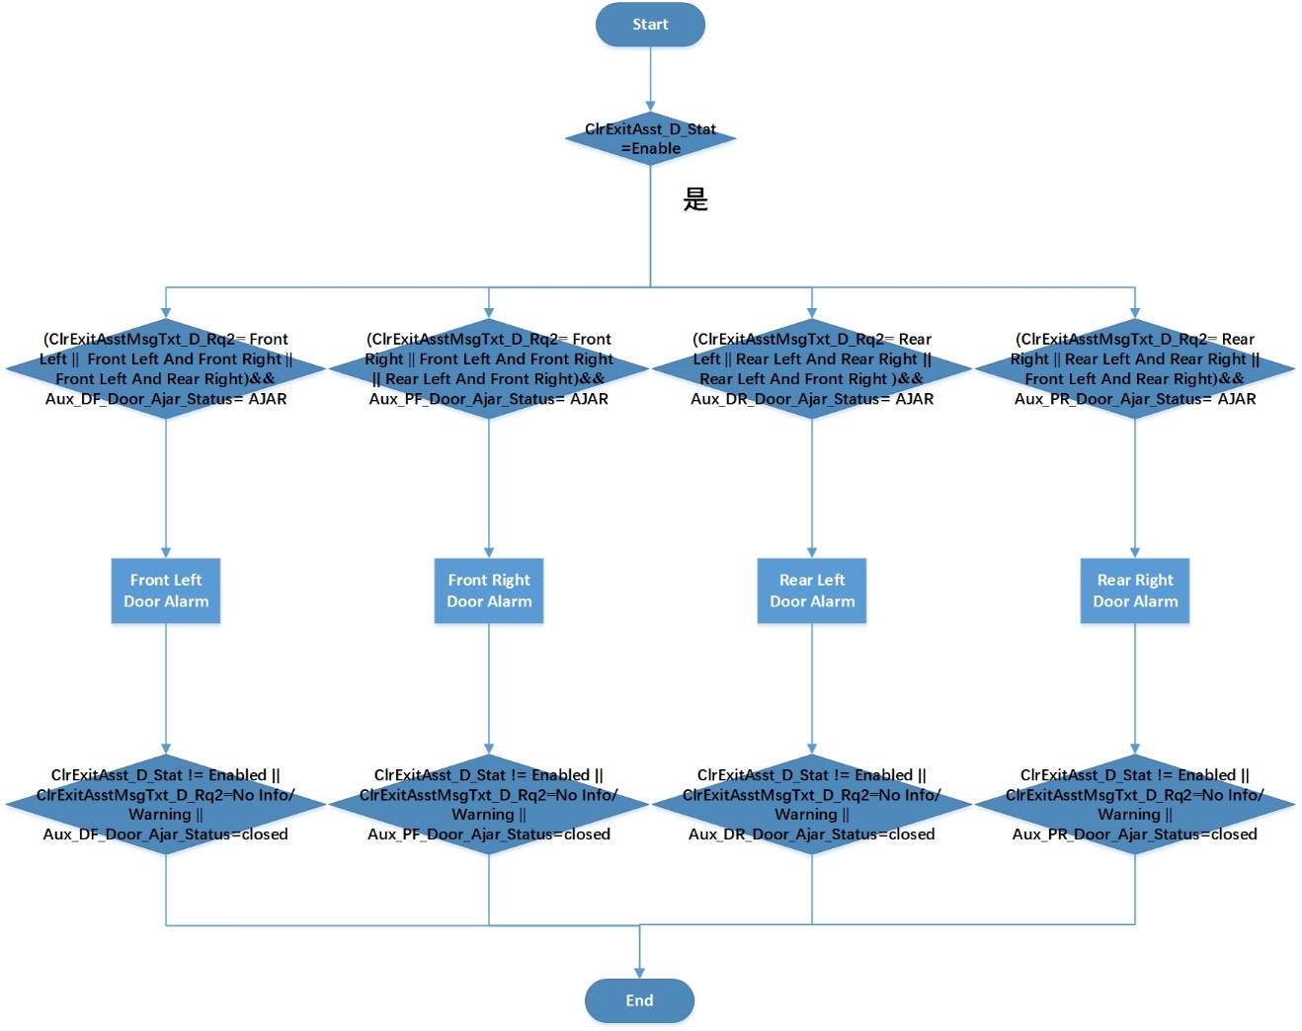

### 3.1.6 Driver Mode

Function description:

Set RGB LED’s color

Function description:

Bus input signal as follows:

|  |  |  |  |  |
| --- | --- | --- | --- | --- |
| Signal Name | Signal Desc | Signal Len | Signal Value Desc | note |

|  |  |  |  |  |
| --- | --- | --- | --- | --- |
| Aux_Day_Night_Status | 白天夜晚状态 | 2 | 0:NULL 1:Day 2:Night 3:NotUsed | BCM |

|  |  |  |  |  |
| --- | --- | --- | --- | --- |
| Aux_ALM_Set | open | 2 | 0:invalid  1:close  2:open | IVI |
| Aux_AmbLghtDrvMde_D_Rq | auto | 1 | 0x0: manual  0x1：auto | IVI |
| Aux_Customer_Color | SDM mode color index | 2 | 1:normal-Orange  2:eco-Soft Blue  3:sport-red | BCM LIN |

Function description:

1. Enabling conditions：（A＆B＆C&D）

A. Power supply voltage within normal operating range.

B. LIN communication normal.

C. LED function normal.

D. Temperature within normal range

2. Trigger conditions：（A&B&C）

A. Aux_ALM_Set = open

B. Aux_AmbLghtDrvMde_D_Rq = auto

C. Aux_Customer_Color = 1,2,3.

Signal Aux_Customer_Color is from BCM LIN, means driver mode color index.

3. Execute output:

1. All Ambient Lighting Fade ON (1s)
2. Selected Color:

If Aux_Customer_Color =normal, Selected Color= Orange（255,150,0）

If Aux_Customer_Color =eco, Selected Color= Soft Blue（115,115,255）

If Aux_Customer_Color =sport, Selected Color=Red（255,0,45）

4. Flow chart：

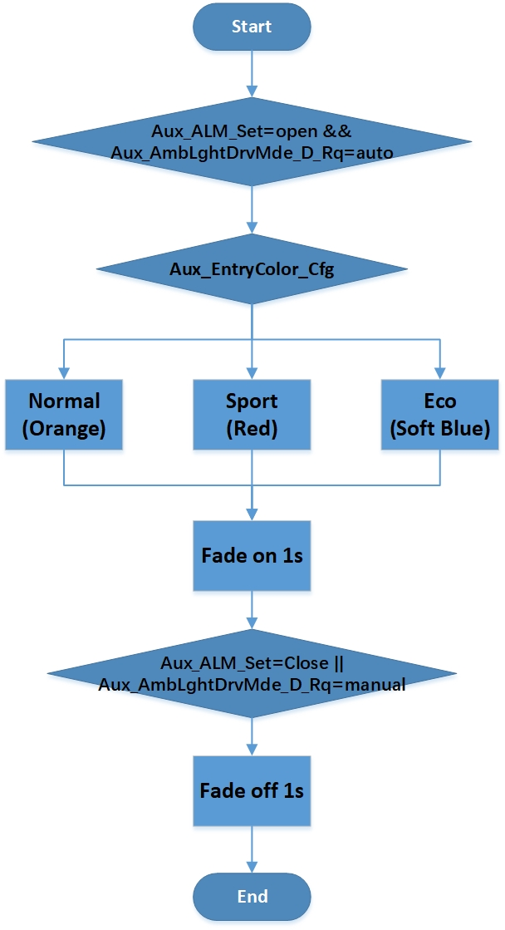

### 3.1.8 Static mode

Function description

Turn on and off static mode

Signal description

Bus input signal as follows:

|  |  |  |  |  |
| --- | --- | --- | --- | --- |
| Signal Name | Signal Desc | Signal Len | Signal Value Desc | note |

|  |  |  |  |  |
| --- | --- | --- | --- | --- |
| Aux_Day_Night_Status | 白天夜晚状态 | 2 | 0:NULL 1:Day 2:Night 3:NotUsed | BCM |

|  |  |  |  |  |
| --- | --- | --- | --- | --- |
| Aux_ALM_Set | open | 2 | 0:invalid  1:close  2:open | IVI |
| Aux_AmbLghtDrvMde_D_Rq | manual | 1 | 0x0: manual  0x1：auto | IVI |
| Aux_Color_Mode | static | 3 | 0:invalid  1:static  2:dynamic  3:customize  4:music | IVI |
| Aux_Static_Intensity_Value | 0-100 | 7 | 0-100(%) | IVI |
| Aux_Static_Color_Value | 0-127 | 8 | 0-255(color num) | IVI |

Function description

1. Enabling conditions：（A＆B＆C&D）

A. Power supply voltage within normal operating range.

B. LIN communication normal.

C. LED function normal.

D. Temperature within normal range

2. Trigger conditions：（A＆B&C）

A、Aux_ALM_Set=open

B、Aux_AmbLghtDrvMde_D_Rq= manual

C、Aux_Color_Mode =static

3. Execute output:

A. All Ambient Lights set color= Aux_Static_Color_Value, Intensity = Aux_Static_Intensity_Value

B. Fade on 1s.

4. Flow chart：

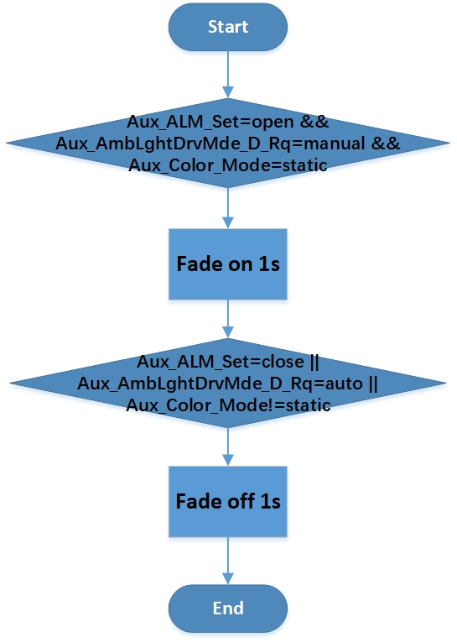

### 3.1.7 Music rhythm

Function description

Turn on and off music rhythm

Signal description

Bus input signal as follows:

|  |  |  |  |  |
| --- | --- | --- | --- | --- |
| Signal Name | Signal Desc | Signal Len | Signal Value Desc | note |

|  |  |  |  |  |
| --- | --- | --- | --- | --- |
| Aux_Day_Night_Status | 白天夜晚状态 | 2 | 0:NULL 1:Day 2:Night 3:NotUsed | BCM |

|  |  |  |  |  |  |  |  |  |
| --- | --- | --- | --- | --- | --- | --- | --- | --- |
| Aux_ALM_Set | open | | | 2 | | 0:invalid  1:close  2:open | IVI | |
| Aux_AmbLghtDrvMde_D_Rq | manual | | | 1 | | 0x0: manual  0x1：auto | IVI | |
| Aux_Static_Intensity_Value | 0-100 | | | 7 | | 0-100(%) | IVI | |
| Aux_Color_Mode | | music | 3 | | 0:invalid  1:static  2:dynamic  3:customize  4:music | | | IVI |
| Aux_Music_Rate_Level | Music rate Level | | | 4 | | 0:0-63hz  1:64-127hz  2:128-255hz  3:256-511hz  4:512-1023hz  5:1023-2047hz  6:2048-4095hz  7:4096-8191hz  8:8192-16383hz | IVI | |
| Aux_Music_Range_Level | Music range Level | | | 3 | | 0:0-15  1:16-31  2:32-47  3:48-63  4:64-79  5:80-95  6:96-111  7:112-127 | IVI | |

Function description

1. Enabling conditions：（A＆B＆C&D）

A. Power supply voltage within normal operating range.

B. LIN communication normal.

C. LED function normal.

D. Temperature within normal range

2. Trigger conditions：（A＆B&C）

A、Aux_ALM_Set=open

B、Aux_AmbLghtDrvMde_D_Rq= manual

C、Aux_Color_Mode = music

3. Execute output:

A. All Ambient Lighting join effect.

B. Aux_Music_Rate_Level control Intensity, Aux_Music_Range_Level control color

C. Select 9 levels Intensity.

|  |  |
| --- | --- |
| Aux_Music_Rate_Level | Intensity |
| 0 | Aux_Static_Intensity_Value*1/9 |
| 1 | Aux_Static_Intensity_Value*2/9 |
| 2 | Aux_Static_Intensity_Value*3/9 |
| 3 | Aux_Static_Intensity_Value*4/9 |
| 4 | Aux_Static_Intensity_Value*5/9 |
| 5 | Aux_Static_Intensity_Value*6/9 |
| 6 | Aux_Static_Intensity_Value*7/9 |
| 7 | Aux_Static_Intensity_Value*8/9 |
| 8 | Aux_Static_Intensity_Value*1 |

D. Select 8 colors from all of 128 colors.

|  |  |  |  |  |  |  |
| --- | --- | --- | --- | --- | --- | --- |
| 67 | 0.6414 | 0.3386 | 255 | 21 | 0 |  |
| 56 | 0.5103 | 0.4410 | 255 | 195 | 0 |  |
| 52 | 0.4801 | 0.4646 | 255 | 255 | 0 |  |
| 35 | 0.1867 | 0.4905 | 0 | 255 | 51 |  |
| 20 | 0.1661 | 0.2779 | 0 | 255 | 231 |  |
| 126 | 0.1964 | 0.1218 | 41 | 9 | 255 |  |
| 89 | 0.3398 | 0.1860 | 255 | 30 | 255 |  |
| 104 | 0.3146 | 0.2780 | 255 | 255 | 255 |  |

E. If music is pause, ambient light keep current color until music start.

F. If music is pause from very beginning, ambient light set color=56(255, 195, 0), intencity = 50% * Aux_Static_Intensity_Value

4. Flow chart：

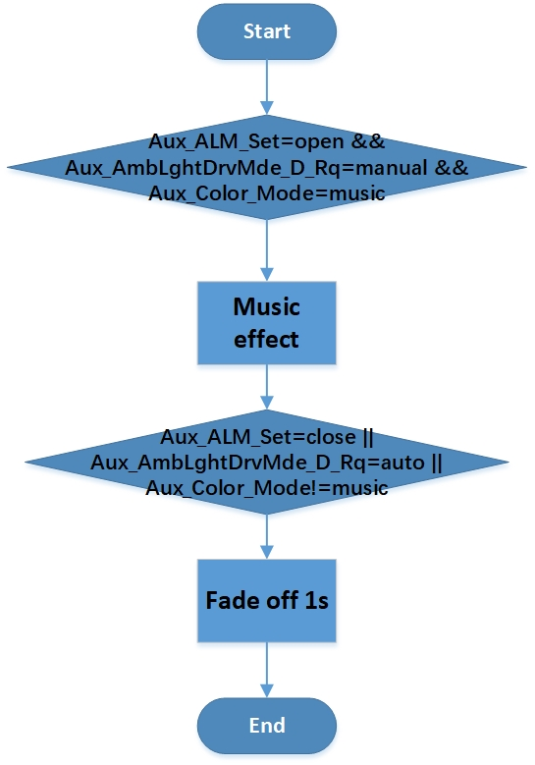

### 3.1.9 Dynamic color

Function description

The ambient light chooses the dynamic color mode, and the ambient light color changes with the change of the dynamic mode, while breathing.

Signal description:

Bus input signal as follows:

|  |  |  |  |  |
| --- | --- | --- | --- | --- |
| Signal Name | Signal Desc | Signal Len | Signal Value Desc | note |

|  |  |  |  |  |
| --- | --- | --- | --- | --- |
| Aux_Day_Night_Status | 白天夜晚状态 | 2 | 0:NULL 1:Day 2:Night 3:NotUsed | BCM |

|  |  |  |  |  |
| --- | --- | --- | --- | --- |
| Aux_ALM_Set | open | 2 | 0:invalid  1:close  2:open | IVI |
| Aux_AmbLghtDrvMde_D_Rq | manual | 1 | 0x0: manual  0x1：auto | IVI |
| Aux_Static_Intensity_Value | 0-100 | 7 | 0-100(%) | IVI |
| Aux_Color_Mode | dynamic | 3 | 0:invalid  1:static  2:dynamic  3:customize  4:music | IVI |
| Aux_Dynamic_Color | 1-5 | 3 | 0:invalid  1:surprise me  2:ocean heart  3:deep forest  4:Moden city  5:Warm heart | IVI |

Function description

1. Enabling conditions：（A＆B＆C&D）

A. Power supply voltage within normal operating range.

B. LIN communication normal.

C. LED function normal.

D. Temperature within normal range

2. Trigger conditions：（A&B&C&D）

A. Aux_ALM_Set = open

B、Aux_AmbLghtDrvMde_D_Rq= manual

C. Aux_Color_Mode = dynamic

D. Aux_Dynamic_Color = 1-5

3.Execute output:

1. When the dynamic color is selected surprise me mode, the all ambient lights select random color from all of 128 colors. The cycle time of each color is 3s. Brightness ranges from 0% to Aux_Static_Intensity_Value for the first 1.5s and from Aux_Static_Intensity_Value to 0% for the last 1.5s.
2. When the dynamic color is selected ocean heart mode, the all ambient lights are cycled in accordance with the color in the 128 color table from 20 to 1, then 1 to 20. The cycle time of each color is 3s. Brightness ranges from 0% to Aux_Static_Intensity_Value for the first 1.5s and from Aux_Static_Intensity_Value to 0% for the last 1.5s.

|  |  |  |  |  |  |  |
| --- | --- | --- | --- | --- | --- | --- |
| 1 | 0.1547 | 0.1592 | 0 | 80 | 255 |  |
| 2 | 0.1554 | 0.1667 | 0 | 90 | 255 |  |
| 3 | 0.1561 | 0.1740 | 0 | 100 | 255 |  |
| 4 | 0.1568 | 0.1811 | 0 | 110 | 255 |  |
| 5 | 0.1677 | 0.2223 | 7 | 111 | 255 |  |
| 6 | 0.1581 | 0.1947 | 0 | 130 | 255 |  |
| 7 | 0.1587 | 0.2013 | 0 | 140 | 255 |  |
| 8 | 0.1594 | 0.2076 | 0 | 150 | 255 |  |
| 9 | 0.1600 | 0.2138 | 0 | 160 | 255 |  |
| 10 | 0.1605 | 0.2199 | 0 | 170 | 255 |  |
| 11 | 0.1851 | 0.2744 | 23 | 174 | 255 |  |
| 12 | 0.1617 | 0.2315 | 0 | 190 | 255 |  |
| 13 | 0.1622 | 0.2371 | 0 | 200 | 255 |  |
| 14 | 0.1627 | 0.2425 | 0 | 210 | 255 |  |
| 15 | 0.1632 | 0.2478 | 0 | 220 | 255 |  |
| 16 | 0.1637 | 0.2530 | 0 | 230 | 255 |  |
| 17 | 0.1642 | 0.2581 | 0 | 240 | 255 |  |
| 18 | 0.1649 | 0.2655 | 0 | 255 | 255 |  |
| 19 | 0.1655 | 0.2715 | 0 | 255 | 243 |  |
| 20 | 0.1661 | 0.2779 | 0 | 255 | 231 |  |

1. When the dynamic color is selected deep forest mode, the all ambient lights are cycled in accordance with the color in the 128 color table 28 to 47, then 47 to 28. The cycle time of each color is 3s. Brightness ranges from 0% to Aux_Static_Intensity_Value for the first 1.5s and from Aux_Static_Intensity_Value to 0% for the last 1.5s.

|  |  |  |  |  |  |  |
| --- | --- | --- | --- | --- | --- | --- |
| 28 | 0.1733 | 0.3521 | 0 | 255 | 135 |  |
| 29 | 0.1746 | 0.3657 | 0 | 255 | 123 |  |
| 30 | 0.1761 | 0.3808 | 0 | 255 | 111 |  |
| 31 | 0.1777 | 0.3976 | 0 | 255 | 99 |  |
| 32 | 0.1795 | 0.4166 | 0 | 255 | 87 |  |
| 33 | 0.1960 | 0.4818 | 8 | 255 | 83 |  |
| 34 | 0.1839 | 0.4624 | 0 | 255 | 63 |  |
| 35 | 0.1867 | 0.4905 | 0 | 255 | 51 |  |
| 36 | 0.3482 | 0.5675 | 80 | 255 | 0 |  |
| 37 | 0.3602 | 0.5581 | 90 | 255 | 0 |  |
| 38 | 0.3714 | 0.5494 | 100 | 255 | 0 |  |
| 39 | 0.3819 | 0.5412 | 110 | 255 | 0 |  |
| 40 | 0.3917 | 0.5336 | 120 | 255 | 0 |  |
| 41 | 0.4008 | 0.5265 | 130 | 255 | 0 |  |
| 42 | 0.4094 | 0.5198 | 140 | 255 | 0 |  |
| 43 | 0.4175 | 0.5135 | 150 | 255 | 0 |  |
| 44 | 0.3718 | 0.5378 | 151 | 255 | 5 |  |
| 45 | 0.4322 | 0.5019 | 170 | 255 | 0 |  |
| 46 | 0.4390 | 0.4966 | 180 | 255 | 0 |  |
| 47 | 0.4454 | 0.4916 | 190 | 255 | 0 |  |

1. When the dynamic color is selected moden city mode, the all ambient lights are cycled in accordance with the color in the 128 color table 128 to 90 in even number, then 90 to 128 in even number. The cycle time of each color is 3s. Brightness ranges from 0% to Aux_Static_Intensity_Value for the first 1.5s and from Aux_Static_Intensity_Value to 0% for the last 1.5s.

|  |  |  |  |  |  |  |
| --- | --- | --- | --- | --- | --- | --- |
| 90 | 0.3378 | 0.1935 | 255 | 45 | 255 |  |
| 92 | 0.3339 | 0.2077 | 255 | 75 | 255 |  |
| 94 | 0.3302 | 0.2210 | 255 | 105 | 255 |  |
| 96 | 0.3268 | 0.2337 | 255 | 135 | 255 |  |
| 98 | 0.3235 | 0.2456 | 255 | 165 | 255 |  |
| 100 | 0.3189 | 0.2624 | 255 | 210 | 255 |  |
| 102 | 0.3174 | 0.2677 | 255 | 225 | 255 |  |
| 104 | 0.3146 | 0.2780 | 255 | 255 | 255 |  |
| 106 | 0.3130 | 0.3454 | 233 | 245 | 255 |  |
| 108 | 0.3005 | 0.2620 | 215 | 215 | 255 |  |
| 110 | 0.2925 | 0.2530 | 195 | 195 | 255 |  |
| 112 | 0.2837 | 0.2431 | 175 | 175 | 255 |  |
| 114 | 0.2741 | 0.2323 | 155 | 155 | 255 |  |
| 116 | 0.2635 | 0.2203 | 135 | 135 | 255 |  |
| 118 | 0.2517 | 0.2070 | 115 | 115 | 255 |  |
| 120 | 0.2386 | 0.1922 | 95 | 95 | 255 |  |
| 122 | 0.2239 | 0.1756 | 75 | 75 | 255 |  |
| 124 | 0.2073 | 0.1569 | 55 | 55 | 255 |  |
| 126 | 0.1964 | 0.1218 | 41 | 9 | 255 |  |
| 128 | 0.1494 | 0.1041 | 0 | 9 | 255 |  |

1. When the dynamic color is selected warm heart mode, the all ambient light are cycled in accordance with the color in the 128 color table 51 to 70, then 70 to 51 . The cycle time of each color is 3s. Brightness ranges from 0% to Aux_Static_Intensity_Value for the first 1.5s and from Aux_Static_Intensity_Value to 0% for the last 1.5s.

|  |  |  |  |  |  |  |
| --- | --- | --- | --- | --- | --- | --- |
| 51 | 0.4680 | 0.4740 | 230 | 255 | 0 |  |
| 52 | 0.4801 | 0.4646 | 255 | 255 | 0 |  |
| 53 | 0.4871 | 0.4591 | 255 | 240 | 0 |  |
| 54 | 0.4944 | 0.4534 | 255 | 225 | 0 |  |
| 55 | 0.5022 | 0.4473 | 255 | 210 | 0 |  |
| 56 | 0.5103 | 0.4410 | 255 | 195 | 0 |  |
| 57 | 0.5189 | 0.4342 | 255 | 180 | 0 |  |
| 58 | 0.5281 | 0.4271 | 255 | 165 | 0 |  |
| 59 | 0.4502 | 0.4081 | 255 | 156 | 38 |  |
| 60 | 0.5480 | 0.4115 | 255 | 135 | 0 |  |
| 61 | 0.5590 | 0.4030 | 255 | 120 | 0 |  |
| 62 | 0.5338 | 0.4227 | 255 | 107 | 0 |  |
| 63 | 0.5830 | 0.3842 | 255 | 90 | 0 |  |
| 64 | 0.5964 | 0.3738 | 255 | 75 | 0 |  |
| 65 | 0.6106 | 0.3626 | 255 | 60 | 0 |  |
| 66 | 0.6260 | 0.3506 | 255 | 45 | 0 |  |
| 67 | 0.6414 | 0.3386 | 255 | 21 | 0 |  |
| 68 | 0.6478 | 0.3336 | 255 | 18 | 0 |  |
| 69 | 0.6539 | 0.3049 | 255 | 0 | 0 |  |
| 70 | 0.6313 | 0.2885 | 255 | 0 | 15 |  |

4. Flow chart：

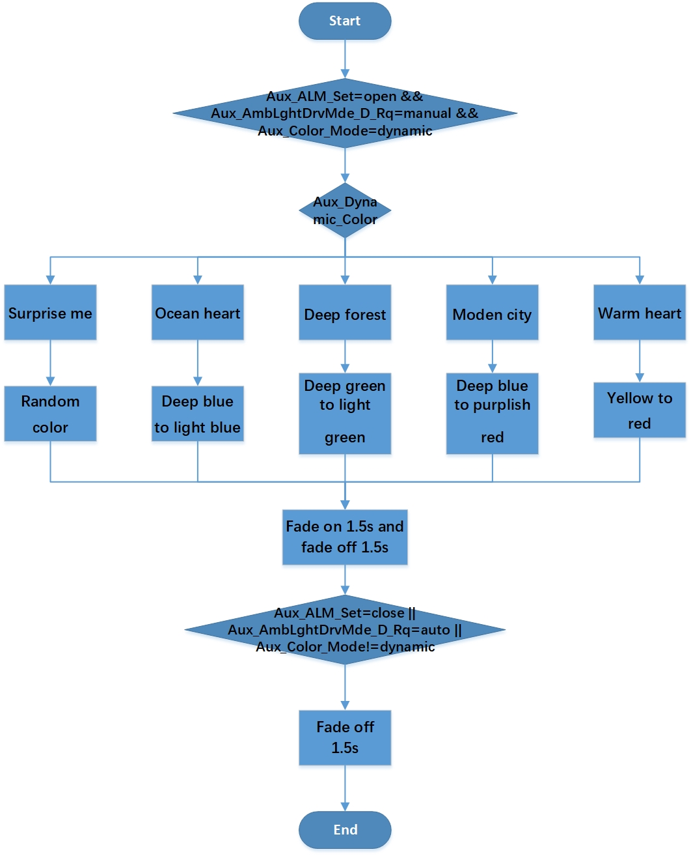

### 3.1.10 customize mode

Function description

Turn on and off static mode

Signal description

Bus input signal as follows:

|  |  |  |  |  |
| --- | --- | --- | --- | --- |
| Signal Name | Signal Desc | Signal Len | Signal Value Desc | note |

|  |  |  |  |  |
| --- | --- | --- | --- | --- |
| Aux_Day_Night_Status | 白天夜晚状态 | 2 | 0:NULL 1:Day 2:Night 3:NotUsed | BCM |

|  |  |  |  |  |
| --- | --- | --- | --- | --- |
| Aux_ALM_Set | open | 2 | 0:invalid  1:close  2:open | IVI |
| Aux_AmbLghtDrvMde_D_Rq | manual | 1 | 0x0: manual  0x1：auto | IVI |
| Aux_Color_Mode | customize | 3 | 0:invalid  1:static  2:dynamic  3:customize  4:music | IVI |
| Aux_IP_Intensity_Value | 0-100 | 7 | 0-100(%) | IVI |
| Aux_IP_Group_Set | 0-1 | 1 | 0:close 1:open | IVI |
| Aux_IP_Color_Value | 0-127 | 8 | 0-255(color num) | IVI |
| Aux_Door_Intensity_Value | 0-100 | 7 | 0-100(%) | IVI |
| Aux_Door_Group_Set | 0-1 | 1 | 0:close 1:open | IVI |
| Aux_Door_Color_Value | 0-127 | 8 | 0-255(color num) | IVI |
| Aux_Foot_Intensity_Value | 0-100 | 7 | 0-100(%) | IVI |
| Aux_Foot_Group_Set | 0-1 | 1 | 0:close 1:open | IVI |
| Aux_Foot_Color_Value | 0-127 | 8 | 0-255(color num) | IVI |

Function description

1. Enabling conditions：（A＆B＆C&D）

A. Power supply voltage within normal operating range.

B. LIN communication normal.

C. LED function normal.

D. Temperature within normal range

2. Trigger conditions：（A＆B&C）

A、Aux_ALM_Set=open

B、Aux_AmbLghtDrvMde_D_Rq= manual

C、Aux_Color_Mode = customize

3. Execute output:

* 1. Hide total intensity, Aux_Static_Intensity_Value not used, only use Aux_IP_Intensity_Value, Aux_Door_Intensity_Value, Aux_Foot_Intensity_Value.
  2. If Aux_IP_Group_Set=open, IP group lights color = Aux_IP_Color_Value and Intensity = Aux_IP_Intensity_Value. If Aux_IP_Group_Set=close, IP group lights close.
  3. If Aux_Door_Group_Set=open, Door group lights color = Aux_Door_Color_Value and Intensity = Aux_Door_Intensity_Value. If Aux_Door_Group_Set=close, Door group lights close.
  4. If Aux_Foot_Group_Set=open, Foot group lights color = Aux_Foot_Color_Value and Intensity = Aux_Foot_Intensity_Value. If Aux_Foot_Group_Set=close, Foot group lights close.

4. Flow chart：

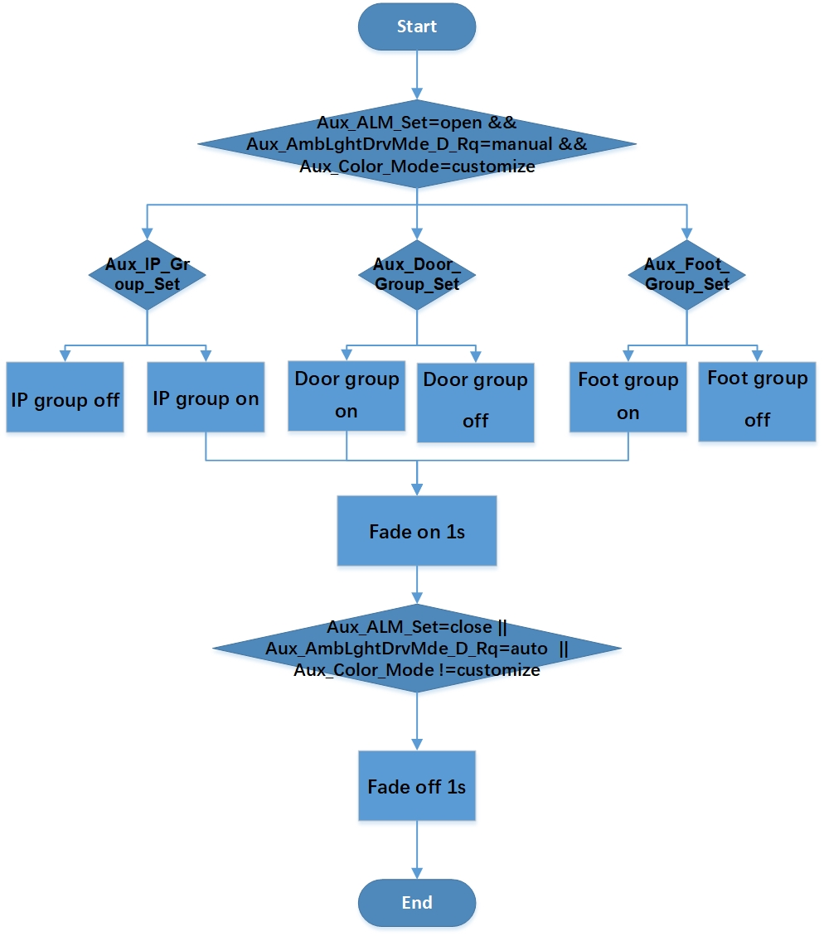

### 3.1.11 Rest mode

Function description

The ambient light chooses the dynamic color mode, and the ambient light color changes with the change of the dynamic mode, while breathing.

Signal description:

Bus input signal as follows:

|  |  |  |  |  |
| --- | --- | --- | --- | --- |
| Signal Name | Signal Desc | Signal Len | Signal Value Desc | note |

|  |  |  |  |  |
| --- | --- | --- | --- | --- |
| Aux_Day_Night_Status | 白天夜晚状态 | 2 | 0:NULL 1:Day 2:Night 3:NotUsed | BCM |

|  |  |  |  |  |
| --- | --- | --- | --- | --- |
| Aux_ALM_Set | open | 2 | 0:invalid  1:close  2:open | IVI |
| Aux_AmbLghtDrvMde_D_Rq | manual | 1 | 0x0: manual  0x1：auto | IVI |
| Aux_Static_Intensity_Value | 0-100 | 7 | 0-100(%) | IVI |
| Aux_Color_Mode | dynamic | 3 | 0:invalid  1:static  2:dynamic  3:customize  4:music | IVI |
| Aux_Dynamic_Color | 2,3,5 | 3 | 0:invalid  1:surprise me  2:ocean heart  3:deep forest  4:Moden city  5:Warm heart | IVI |

Function description

1. Enabling conditions：（A＆B＆C&D）

A. Power supply voltage within normal operating range.

B. LIN communication normal.

C. LED function normal.

D. Temperature within normal range

2. Trigger conditions：（A&B&C&D）

A. Aux_ALM_Set = open

B、Aux_AmbLghtDrvMde_D_Rq= manual

C. Aux_Color_Mode = dynamic

D. Aux_Dynamic_Color = 2,3,5

3.Execute output:

1. When the dynamic color is selected ocean heart mode, the all ambient lights are cycled in accordance with the color in the 128 color table from 20 to 1, then 1 to 20. The cycle time of each color is 3s. Brightness ranges from 0% to Aux_Static_Intensity_Value for the first 1.5s and from Aux_Static_Intensity_Value to 0% for the last 1.5s.

|  |  |  |  |  |  |  |
| --- | --- | --- | --- | --- | --- | --- |
| 1 | 0.1547 | 0.1592 | 0 | 80 | 255 |  |
| 2 | 0.1554 | 0.1667 | 0 | 90 | 255 |  |
| 3 | 0.1561 | 0.1740 | 0 | 100 | 255 |  |
| 4 | 0.1568 | 0.1811 | 0 | 110 | 255 |  |
| 5 | 0.1677 | 0.2223 | 7 | 111 | 255 |  |
| 6 | 0.1581 | 0.1947 | 0 | 130 | 255 |  |
| 7 | 0.1587 | 0.2013 | 0 | 140 | 255 |  |
| 8 | 0.1594 | 0.2076 | 0 | 150 | 255 |  |
| 9 | 0.1600 | 0.2138 | 0 | 160 | 255 |  |
| 10 | 0.1605 | 0.2199 | 0 | 170 | 255 |  |
| 11 | 0.1851 | 0.2744 | 23 | 174 | 255 |  |
| 12 | 0.1617 | 0.2315 | 0 | 190 | 255 |  |
| 13 | 0.1622 | 0.2371 | 0 | 200 | 255 |  |
| 14 | 0.1627 | 0.2425 | 0 | 210 | 255 |  |
| 15 | 0.1632 | 0.2478 | 0 | 220 | 255 |  |
| 16 | 0.1637 | 0.2530 | 0 | 230 | 255 |  |
| 17 | 0.1642 | 0.2581 | 0 | 240 | 255 |  |
| 18 | 0.1649 | 0.2655 | 0 | 255 | 255 |  |
| 19 | 0.1655 | 0.2715 | 0 | 255 | 243 |  |
| 20 | 0.1661 | 0.2779 | 0 | 255 | 231 |  |

1. When the dynamic color is selected deep forest mode, the all ambient lights are cycled in accordance with the color in the 128 color table 28 to 47, then 47 to 28. The cycle time of each color is 3s. Brightness ranges from 0% to Aux_Static_Intensity_Value for the first 1.5s and from Aux_Static_Intensity_Value to 0% for the last 1.5s.

|  |  |  |  |  |  |  |
| --- | --- | --- | --- | --- | --- | --- |
| 28 | 0.1733 | 0.3521 | 0 | 255 | 135 |  |
| 29 | 0.1746 | 0.3657 | 0 | 255 | 123 |  |
| 30 | 0.1761 | 0.3808 | 0 | 255 | 111 |  |
| 31 | 0.1777 | 0.3976 | 0 | 255 | 99 |  |
| 32 | 0.1795 | 0.4166 | 0 | 255 | 87 |  |
| 33 | 0.1960 | 0.4818 | 8 | 255 | 83 |  |
| 34 | 0.1839 | 0.4624 | 0 | 255 | 63 |  |
| 35 | 0.1867 | 0.4905 | 0 | 255 | 51 |  |
| 36 | 0.3482 | 0.5675 | 80 | 255 | 0 |  |
| 37 | 0.3602 | 0.5581 | 90 | 255 | 0 |  |
| 38 | 0.3714 | 0.5494 | 100 | 255 | 0 |  |
| 39 | 0.3819 | 0.5412 | 110 | 255 | 0 |  |
| 40 | 0.3917 | 0.5336 | 120 | 255 | 0 |  |
| 41 | 0.4008 | 0.5265 | 130 | 255 | 0 |  |
| 42 | 0.4094 | 0.5198 | 140 | 255 | 0 |  |
| 43 | 0.4175 | 0.5135 | 150 | 255 | 0 |  |
| 44 | 0.3718 | 0.5378 | 151 | 255 | 5 |  |
| 45 | 0.4322 | 0.5019 | 170 | 255 | 0 |  |
| 46 | 0.4390 | 0.4966 | 180 | 255 | 0 |  |
| 47 | 0.4454 | 0.4916 | 190 | 255 | 0 |  |

1. When the dynamic color is selected warm heart mode, the all ambient light are cycled in accordance with the color in the 128 color table 51 to 70, then 70 to 51 . The cycle time of each color is 3s. Brightness ranges from 0% to Aux_Static_Intensity_Value for the first 1.5s and from Aux_Static_Intensity_Value to 0% for the last 1.5s.

|  |  |  |  |  |  |  |
| --- | --- | --- | --- | --- | --- | --- |
| 51 | 0.4680 | 0.4740 | 230 | 255 | 0 |  |
| 52 | 0.4801 | 0.4646 | 255 | 255 | 0 |  |
| 53 | 0.4871 | 0.4591 | 255 | 240 | 0 |  |
| 54 | 0.4944 | 0.4534 | 255 | 225 | 0 |  |
| 55 | 0.5022 | 0.4473 | 255 | 210 | 0 |  |
| 56 | 0.5103 | 0.4410 | 255 | 195 | 0 |  |
| 57 | 0.5189 | 0.4342 | 255 | 180 | 0 |  |
| 58 | 0.5281 | 0.4271 | 255 | 165 | 0 |  |
| 59 | 0.4502 | 0.4081 | 255 | 156 | 38 |  |
| 60 | 0.5480 | 0.4115 | 255 | 135 | 0 |  |
| 61 | 0.5590 | 0.4030 | 255 | 120 | 0 |  |
| 62 | 0.5338 | 0.4227 | 255 | 107 | 0 |  |
| 63 | 0.5830 | 0.3842 | 255 | 90 | 0 |  |
| 64 | 0.5964 | 0.3738 | 255 | 75 | 0 |  |
| 65 | 0.6106 | 0.3626 | 255 | 60 | 0 |  |
| 66 | 0.6260 | 0.3506 | 255 | 45 | 0 |  |
| 67 | 0.6414 | 0.3386 | 255 | 21 | 0 |  |
| 68 | 0.6478 | 0.3336 | 255 | 18 | 0 |  |
| 69 | 0.6539 | 0.3049 | 255 | 0 | 0 |  |
| 70 | 0.6313 | 0.2885 | 255 | 0 | 15 |  |

### 3.1.12 Intensity define

Function description

The ambient light brightness changes automatically according to the ambient illumination

Signal description

Bus input signal as follows:

|  |  |  |  |  |
| --- | --- | --- | --- | --- |
| Signal Name | Signal Desc | Signal Len | Signal Value Desc | note |
| Aux_Static_Intensity_Value | Intensity Setting | 7 | 0-100(%) | IVI |
| Aux_Day_Night_Status | Day Night Status | 2 | 0:NULL  1:Day  2:Night  3:NotUsed | BCM |

Function description

1. Enabling conditions：（A＆B＆C&D）

A. Power supply voltage within normal operating range.

B. LIN communication normal.

C. LED function normal.

D. Temperature within normal range

2. Trigger conditions：

A、Aux_Day_Night_Status ：0x01 or 0x02

B、Aux_Static_Intensity_Value：0x0-0x64

3. Execute output:

A. When the ambient light receives the current day signal 0x01, the ambient light selects the current actual brightness

B. When the ambient light receives the current night signal 0x02, the ambient light selects a brightness 60% of the current actual brightness

C. When the ambient light receives another signal 0x00or0x03, the ambient light is treated as it is during the day 0x01

Remark：

At 100% brightness, LED light flux is 1.8lm

Day: User can adjust intensity 100%;

Night: If the night signal is received, the brightness is automatically adjusted to 60% of the current intensity;

## ALM LIN feedback

* 1. communication error
  2. temperature alarm：alarm/no alarm
  3. high voltage alarm：alarm/no alarm
  4. low voltage alarm：alarm/no alarm
  5. LED error：fault /no fault

## ALM Priority definition

|  |  |  |  |
| --- | --- | --- | --- |
| **Mode Rank 1** | **Mode Rank 2** | **Mode Rank 3** | **Priority** |
| vehicle  condition mode | radar alarm | - | 1 |
| welcome | entry | 2 |
| exit |
| farewell | entry |
| exit |
| driver mode | normal | - | 3 |
| sport | - |
| eco | - |
| normal mode/rest mode(**\***) | static | - | 4 |
| dynamic | surprise me |
| ocean heart(**\***) |
| deep forest(**\***) |
| Moden city |
| warm heart(**\***) |
| customize | - |
| music |  |

Priorities 1-4 from high to low.

3.3.1 **principle**

1. Divide all modes into two categories, alarm mode and continuous mode. Alarm mode include radar alarm mode, welcome/farewell/normal/driver mode are continuous mode.

2.When one continuous mode changes to alarm mode, the effect will be interrupted(without fade off), alarm mode begin directly. When alarm mode stop, end the alarm effect(with fade off), select mode according to the current vehicle condition(with fade on).

3.When one continuous mode changes to another continuous mode, stop the old continuous mode(with fade off) and begin the new continuous mode(with fade on).

4.When high priority mode is running, and low priority mode’s configuration is changed, IVI should change signal automatically. For example: Aux_AmbLghtDrvMde_D_Rq=auto, the Driver changes the Aux_Color_Mode signal from static to customize, and IVI automatically changes Aux_AmbLghtDrvMde_D_Rq to manual, then the ambient lights enter normal- customize mode .

5. User change normal/driver mode param When radar alarm/welcome/farewell mode is running, ambient light save param but do not change to normal/driver mode effect, keep running radar alarm/welcome/farewell mode effect.

|  |  |  |  |
| --- | --- | --- | --- |
| **From** | **Change To** | **Effect** | **IVI Special Action** |
| welcome | welcome | - |  |
| farewell | 1.Keep effect |  |
| radar alarm | 1.Interrupt welcome mode(without fade off) 2.Begin radar alarm mode |  |
| normal mode | 1.Stop welcome mode(fade off 4s) 2.Begin normal mode(fade on 1s) |  |
| driver mode | 1.Stop welcome mode(fade off 4s) 2.Begin driver mode(fade on 1s) |  |
| farewell | welcome | - |  |
| farewell | - |  |
| radar alarm | 1.Interrupt farewell mode(without fade off) 2.Begin radar alarm mode |  |
| normal mode | - |  |
| driver mode | - |  |
| normal mode | welcome | - |  |
| farewell | 1.Keep effect |  |
| radar alarm | 1.Interrupt normal mode(without fade off) 2.Begin radar alarm mode |  |
| normal mode | - |  |
| driver mode | 1.Stop normal mode(fade off 1s) 2.Begin driver mode (fade on 1s) |  |
| driver mode | welcome | - |  |
| farewell | 1.Keep effect |  |
| radar alarm | 1.Interrupt driver mode(without fade off) 2.Begin radar alarm mode |  |
| normal mode | 1.Stop driver mode(fade off 1s) 2.Begin normal mode (fade on 1s) | 1. IVI set Aux_AmbLghtDrvMde_D_Rq=manual |
| driver mode | - |  |
| radar alarm | welcome | 1.Stop radar alarm mode 2.Begin welcome mode(Fade on 3s) |  |
| farewell | 1.Stop radar alarm mode 2.Begin farewell mode(Fade on 1s) |  |
| radar alarm | - |  |
| normal mode | 1.Stop radar alarm mode 2.Begin normal mode(Fade on 1s) |  |
| driver mode | 1.Stop radar alarm mode 2.Begin driver mode(Fade on 1s) |  |

# Color and Brightness define

Documnet：RGB_128color.xls



# Communication Interface

## LIN communication

### Interface type

The ambient light module acts as a slave node in the lin network with a lin communication rate kbps.19.2

### Peripheral circuit

**Interface circuit requirements aux module vehicle controllers are as follows:：**



The model parameters of each component are as follows: D1 and D2 must be of the specified model, which is to ensure that they are of the same model as RGB ambient light module, so as to ensure that the voltage difference between the LIN bus of the main controller and the slave node to the ground is less than ± 1V, so as to ensure that the LIN bus can work reliably.

D1 -- anti reverse diode, model: BAS21LT1G (on semiconductor)

D2 -- anti reverse diode, model: BAS21LT1G (on semiconductor)

D3 - TVS anti-static transient suppression diode.

D4 - TVS anti-static transient suppression diode.

R1, R2 -- Resistance 2K, resistance error < 1%, package 1206, power 250MW.

C1-1000 PF, tolerance error < 10%, package < 0805, voltage > 50V.

C2-220 PF, tolerance error < 10%, package < 0805, voltage > 50V.

C4 - selected according to the requirements of the chip data book used.

X1 - magnetic bead, package 0603 or 0805, improve the EMC performance of LIN bus.

**Interface circuit requirements for rgb ambient light module are as follows:**



The model parameters of each component are required as follows; among them, D1 must adopt the specified model, which is to ensure the same model as aux module of vehicle controller, so as to ensure that the voltage difference between main controller and slave node LIN bus to ground is less than ± 1V, so as to ensure that LIN bus can work reliably. In addition, C2 and D4 are optional devices, and the installation position is reserved, and the installation is determined according to the EMC test results.

D1 -- anti reverse diode, model: s1mlwhrvg (Taiwan Semiconductor).

D3 - TVS antistatic transient suppression diode, model: smbj28ca (Taiwan Semiconductor).

D4 - TVS antistatic transient suppression diode, model: pesd1lin (Nexperia).

C3-220 PF, tolerance error < 10%, package < 0805, voltage > 50V.

C4 - selected according to the requirements of the chip data book used.

X1 -- zero ohm resistance or bead, default to zero ohm resistance, and decide whether to replace it with bead according to EMC test results; package 0603 or 0805.

# Environmental performance requirements

## Temperature

Storage temperature：-40℃～ +90℃；

Work temperature：-30℃～ +85℃；

Humidity：5%～95%；

voltage：9-16V。

## Mechanical sector indicators

The clearance requirements meet the requirements of the vehicle clearance tolerance.

## Appearance and mechanical structure

Connectors, connectors and connectors should be reliable, electrical contacts are good, no loosening, shedding phenomenon, and should comply with the relevant provisions of Chapter 6 of the gb/t 12281-1990.

## Fundamental performance parameter

The basic performance of the product shall meet the performance requirements specified in the drawings.

## EMC

shall comply with the requirements specified in the Ford Company Test Specification.

## Environmental suitability

The environmental test shall comply with the provisions of the general test requirements for Ford components.

## Vibration test

The vibration test shall comply with the provisions of the general test requirements for Ford components.。

## Drop test

Drop test shall be in accordance with Ford parts general test requirements.

## Mechanical impact test

Mechanical impact test shall be in accordance with Ford parts general test requirements.

## Temperature and humidity resistance cycle

The temperature and humidity cycling test shall be in accordance with Ford's general test requirements for parts.

## Switch durability

No switch button.

## Normal voltage cycle

All functions of the product work normally after the voltage cycling test.

## Waterproof and dustproof test

There is no dust and water-proof requirement.。

## Resistance to abnormal power supply voltage

The abnormal voltage resistance test shall be in accordance with Ford parts general test requirements.

# Other requirements

## Oboundary dimension

33*18*17.5（mm）

## outline dimension drawing of light source box

18mm

17.5mm

 

33mm

## Weight

8g

## Installation position

The installation position of the component is the end position of the optical waveguide.

## Service life

3 years or 100000 km

## Part marking requirements

The marking of parts shall be in accordance with the relevant requirements of Party.

## Requirements for tooling, clamps, molds and inspection tools

The inspection fixture shall meet the requirements of Ford.

## Requirements for prohibited substances

The materials used for parts shall meet the requirements of GB / T 30512 requirements for prohibited substances of automobiles;

## Transportation and packaging requirements

According to the relevant requirements of Party A's logistics department, including but not limited to:

The outside of the packing box shall be marked with: the name and address of the receiving unit; the name and address of the manufacturer; the quantity, quality and volume of the package; the date of delivery; the name and address of the shipping unit; the words "moisture proof", "shockproof", "handle with care" and other words. The pictorial mark shall be in accordance with the provisions of GB / T 191-2000.